**Stability**

One of the most fundamental aspects in determining the stability of an aircraft, and the element most easily adjusted in paper, is the relationship between the center of gravity and the center of lift. In the most general sense, the center of lift needs to be behind the center of gravity for the plane to be stable. The reasons for this are illustrated in the figure to the right:

While there are mathematical models for determining exactly how stable a plane will be, they are complicated, and require the determination of values that are difficult to derive with a paper airplane. As such, it will be assumed that the more forward of the center of lift the center of gravity is, the more stable the airplane. In reality, too much distance leads to problem and the ideal is somewhere in the middle, but this is hard to determine without math that will not be used here. It will also be assumed that the more stable the airplane, the better it is as an airplane, as accuracy can be tuned by slight trimming.

**In other words, the more forward of the center of lift the center of gravity is, the better the paper airplane.**

**Stability and Paper Aircraft**

Here, data will be collected on the center of gravity and the center of lift. Specifically, the center of gravity and center of lift will be found, and from there, the distance between them as a percent of the total length of the plane will be derived. The plane with the highest percentage value will be deemed the most stable.

As the center of lift and the center of gravity are going to be found experimentally, some methodology is in order.

1. Center of gravity: The center of gravity will be determined with a simple balance test. The point at which the plane is perfectly balanced on a fingertip will be marked off.
2. Center of lift: As center of lift is the point at which all lift can be considered as acting upon, the plane will be placed with the top of the wing directly facing a fan. The point on the body at which the plane can be held to keep it at rotational equilibrium will be marked off as the center of lift.

Data is collected below. Note that recorded distance for each center is given as the measurement from that point to the nose.

|  |  |  |  |  |
| --- | --- | --- | --- | --- |
| Plane | Body Length | Center of Gravity | Center of Lift | (CG-CL) / Body Length x 100 |
| A | 20.2 cm | 8.5 cm | 13.1 cm | 22.8% |
| B | 14.5 cm | 7.5 cm | 10.9 cm | 23.4% |
| C | 14.1 cm | 5.6 cm | 9.3 cm | 26.2% |
| D | 27.9 cm | 15.4 cm | 19.4 cm | 14.3% |

When these values are compared, several interesting results emerge. Clearly, by the standards established for this examination, Plane D, the Basic Dart, is far inferior to every other plane. Among the other planes, though, the results we determine are much closer, with the distance between center of lift and center of gravity as a percentage of body length varies between the three by less than 4%. Nevertheless, Plane C, the Hammer, is, by this project’s standards, the best plane of the four. Non-scientific flight tests also confirm this. The Hammer flies better in real life than any of the other four, and by a far more significant margin than the 2.8% difference between it and the Harrier would suggest.

**Background**

The Freshmen Engineering Experience Engineering Design Project required students to come up with a design for a paper airplane that would fly accurately in order to hit targets at varying distances. The only materials given were blank sheets of 8.5” x 11” paper, tape, and paper clips, with a time limit for of 20 minutes for research and brainstorming, and 1 hour for prototyping, construction, and testing.

After researching online for the best possible paper airplane already made, we chose to create our own based off of the hammer design. In order to maximize the effectiveness of constructional soundness of the plane, we made each fold extremely sharp by pressing the paper against a hard surface and using a flat, hard object like a pencil to create the fold. We experimented with the use of tape and paperclips to aid in preventing excessive lift and the plane unfolding, but in the end we decided against the use of these materials and built the plane out of only a single sheet of paper.

We found that the simpler designs were most efficient in a time spent to effectiveness-towards-goal ratio. In other words, as more time was spent on design and folding, returns diminished. The first attempted design was the traditional paper airplane, also known as the “arrow” or “dart”. It was found to be controllable and accurate to a moderate degree, and took very little time to construct. However, the plane was not capable of achieving our goal. Modifications were attempted to the design including folding the front for an altered center of gravity, and folding the wings for more lift. The most effective design was found to be the “hammer”, a front-heavy, small winged plane with a fairly complicated design process involving many folds. This design was found to fight the wind best and be the easiest to throw accurately. It also held its flight path the best, while other planes were susceptible to minor environmental factors. The downsides to this design were all derivative of the complication of it. It was very difficult to create perfect folds, which would cause irregularities in flight. There were also a large number of folds, leaving more potential areas for mistakes and taking more time to produce. Even more complicated designs which involved cutting the paper could have been attempted, but it was determined that they would create too much complication and therefore room for error. Overall, the “hammer” design was found to be most effective at hitting the target consistently, which none of the simpler designs seemed capable of achieving.

For this project, we will be taking the ideas of the first project and expanding on certain aspects of the plane’s aerodynamics to develop and construct the most aerodynamic plane possible incorporating material discussed in class that would be applicable to a more “real world” project such as minimal “machining” costs. We will allow ourselves the same materials for construction, but will add an extra variable of cost of construction in the form of folds representing “machining” costs in a real world environment.

**Manufacturing**

The actual manufacturing of a product requires the manufacturer to take into account several factors such as time to manufacture, component costs, equipment costs, employee costs, overhead fees, and safety. When moving forward with the manufacturing of a product, companies strive to balance all of these variables so as to maximize overall profit, yet still yield results in a speedy fashion.

* **Physical Costs:** For the purposes of this project, we chose to combine the “physical” costs into a lump sum of $1,000 per fold of the paper. This price is completely subjective and was chosen for ease of calculations, and in no way accurately represents the costs of real life manufacturing costs. However, this simple representation will serve our purpose well enough.

*See graph to right

By looking at solely physical manufacturing cost, it is obvious that the plane D, the “Basic Dart”, is the most economically viable choice. This assumption does however only take into account a single variable, and thus could end up having a number of less effective attributes than the other three designs. The overall choice of the supervising engineer should be to take the physical cost of the product and compare it with all other variables, to come up with the best option for the client.

**Manufacturing Cont.**

In addition to physical costs of manufacturing as mentioned above, there are additional non-physical costs that go along with the production of a design. These include employee wages and overhead fees. These two aspects of manufacturing share one thing in common: they depend on the amount of time spent constructing the project. The shorter the construction time, the lower the cost. However, moving too quickly could cause mistakes that would have otherwise been avoided if more time was spent making sure every part of the design gets implemented correctly.

* **Non-Physical Cost:** As above, we decided to combine these two variables into one time dependent cost, set at $200 per 10 seconds of construction, rounded to the nearest 10 seconds. Again, this number was chosen for ease of calculation as well as to allow a significant amount of difference between our chosen designs.

*See graph to right

Obviously, in a real world situation, these numbers are extremely subjective, specifically to the skill of the employees working on the project. To attempt to counteract this, we each constructed a single model of each design, and averaged our build times together to try and represent an industrial average cost.

Taking this data, it is clear that the Hammer design is the most expensive to make based on non-physical manufacturing costs, with the Basic Dart being the least expensive. This, as above, only looks at one variable of cost, and thus is not advised to solely base the final design decision on just this information, but a combination of all information.

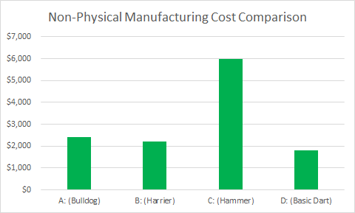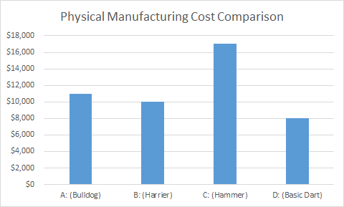

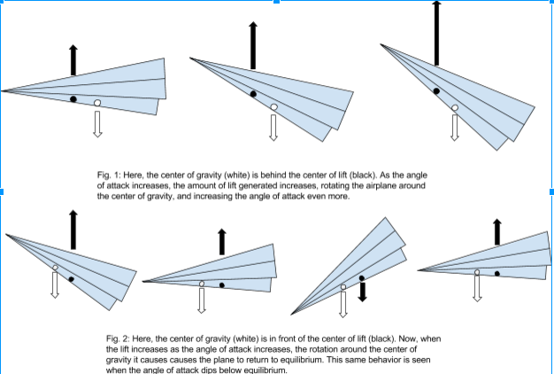

**Figures of Merit**

While we can construct methods of comparing the four planes based on singular metrics, such as aerodynamic stability or cost to manufacture, it is somewhat more difficult to compare them with regards to all these metrics simultaneously. To accomplish this, a tool known as the figures of merit table will be used. Essentially, each metric by which the airplanes will be compared is assigned a percentage weight, and each plane is assigned a value from 1 to 5 for that metric based on how well it measures up. Each “score” is multiplied by the weight for that metric, and a total score is calculated across multiple metrics.

Here, the metrics used are the stability of plane, its ease of manufacture (represented by the time to construct), and its manufacturing cost (the number of folds).

They will be weighted as following:

-Stability: 65%

Stability is the most important aspect of a plane, as it determines how successful the plane is at doing the job of a plane - flying. No matter how cheap the plane if, if it does not fly, it is a failure.

-Ease of Manufacture: 15%

While manufacturing complexity is a significant element, it is less important that the more concrete cost to manufacture, and much less important than the quality of flight.

-Cost to Manufacture: 20%

While very important, the cost to manufacture is still less important than the flight performance of the plane.

|  |  |  |  |  |
| --- | --- | --- | --- | --- |
| Metric | Plane A | Plane B | Plane C | Plane D |
| Stability | 3 | 4 | 5 | 2 |
| Ease of Manufacture | 4 | 3 | 2 | 5 |
| Cost to Manufacture | 3 | 4 | 2 | 5 |
| Total Score | 3.15 | 3.85 | 3.95 | 3.05 |

**Economics**

Combining multiple cost variables, a conclusion can be drawn as to the most logical design choice based on price.

* **Physical Manufacturing Data:**
* Bulldog: $11,000
* Harrier: $10,000
* Hammer: $17,000
* Basic Dart: $8,000
* **Non-Physical Manufacturing Data:**
  + Bulldog: $2,400
  + Harrier: $2,200
  + Hammer: $6,000
  + Basic Dart: $1,800
* **Total Costs:**
  + Bulldog: $13,400
  + Harrier: $12,200
  + Hammer: $23,000
  + Basic Dart: $9,800

From this data, it is clear to see that the Basic Dart design is the most financially viable with the Hammer design being the least financially viable. Of course, economic factors include not just financial variables, but others as well. In this case, the efficiency of the planes during flight (composed of calculations of stability). This idea is expressed in the Figures of Merit table.

**Conclusion**

When this project was assigned in class, experimental testing found that the Hammer was the best plane design for the job; in other words, from a pure engineering design perspective standpoint, the Hammer was the superior design.

Engineering, though, is more than design. In the context of this class, engineering economics is also a critical element. When economic evaluations are rolled into the evaluations of the planes, the results change. The Hammer is still the superior plane of the group, but it is an economic disaster compared to the other options; in the figure of merits comparison, it is bolstered only by its flight performance. However, it only tops the group by the slimmest of margins, trailed narrowly by the Harrier design. As such, should a situation present itself where economic factors are more critical, such as when low cost is requested by a client, the Harrier may become the new best option.

While the assumption that the Hammer was the best design was objectively correct on a pure design perspective, when economics are considered, the picture becomes less clear, and the final result is a sort of toss-up between the Harrier and the Hammer, with the Harrier becoming the more successful overall design as economic factors are more and more heavily valued.

**Paper Airplane**

**Stability/Economics**

**By:**

**Colin Riggert**

**Hunter Black**

**John Seefeldt**